**Controlled Assessment 2015**

**-Assessment task 1**

**Analysis**

* Ask for a name
* 10 randomly generated questions
  + Smaller numbers for primary school age children
* Randomly generated signs +-*
* Asking for an answer
  + Validation so only integers are excepted as answers
* Output whether the answer given is correct or not
* Give a score out of 10 at the end

**Design**

**Development**

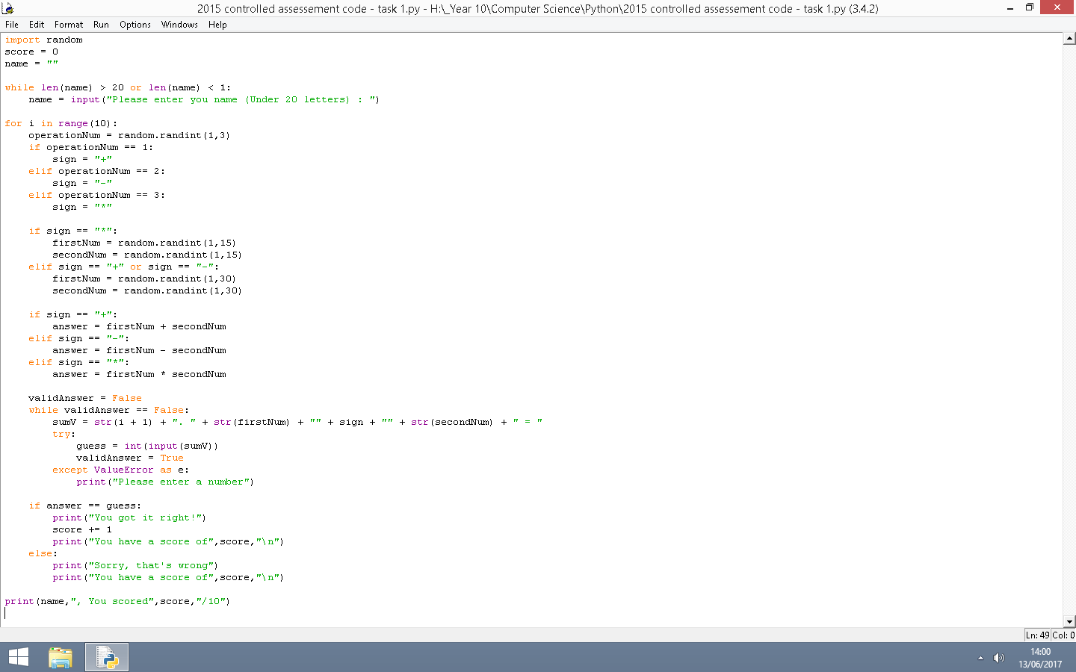

**-Assessment task 2**

**Analysis**

* Three separate classes
* Scores assigned to a name
* Name and Score separate for later use in task 3

**Design**

Built on the code from task 1

**Development**

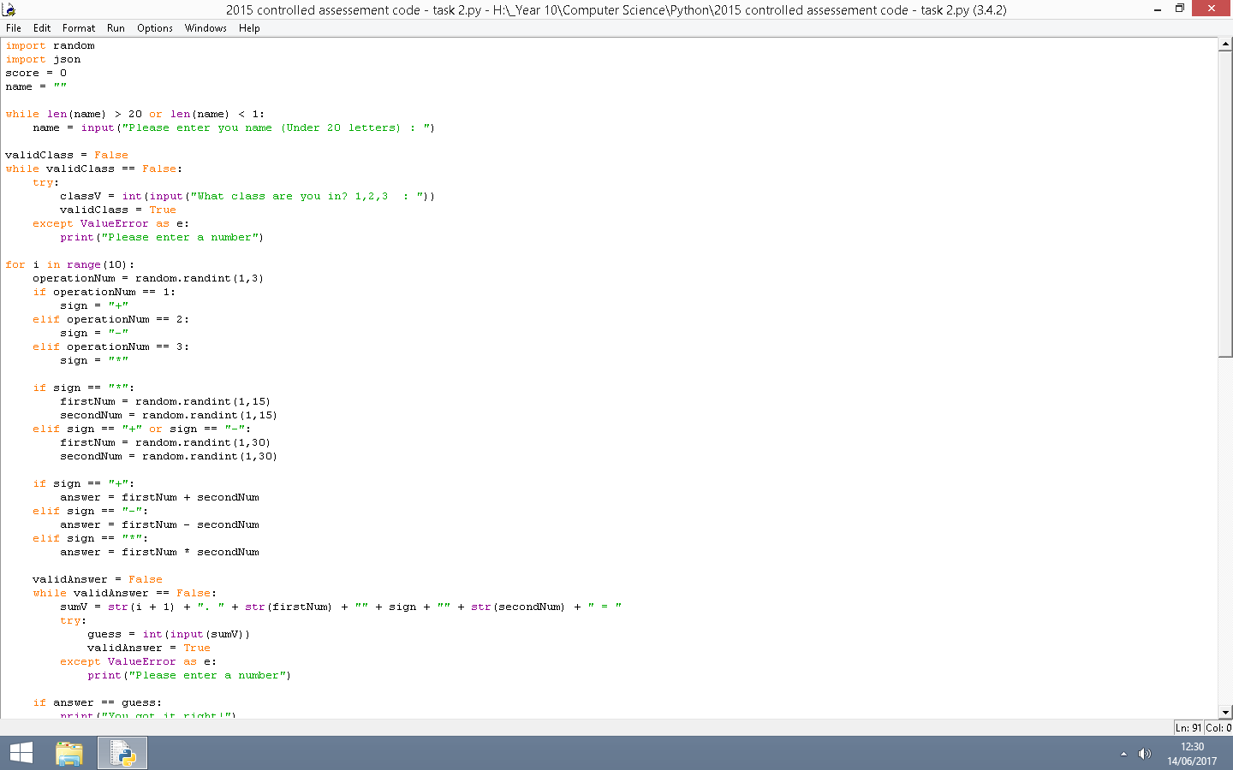

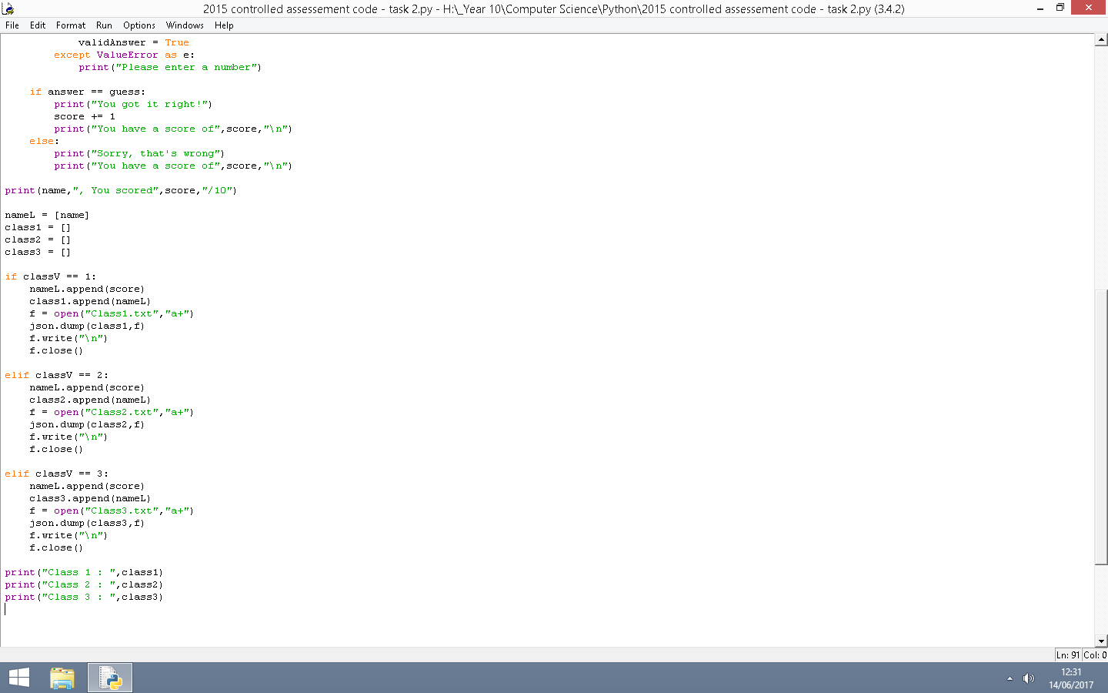

**-Assessment task 3**

**Analysis**

* Selection between classes
* Saving three highest scores for each student
* A sorting system
  + Alphabetical order
  + Highest scores. Highest to lowest
  + Average score. Highest to lowest

**Design**

Built on the code from task 1 and task 2

**Development**